1. Create a table product-product id,product name, product price(include necessary constraints)

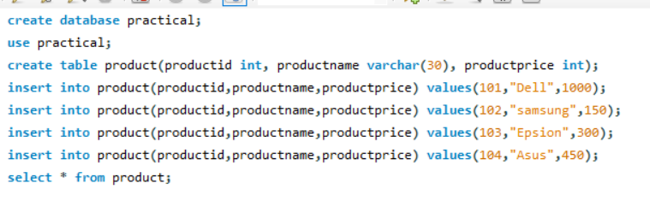

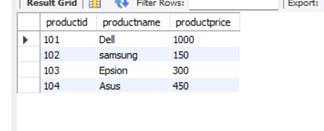

1. Create table sales- sales id, customer id, product id, quantity(include necessary constraints)

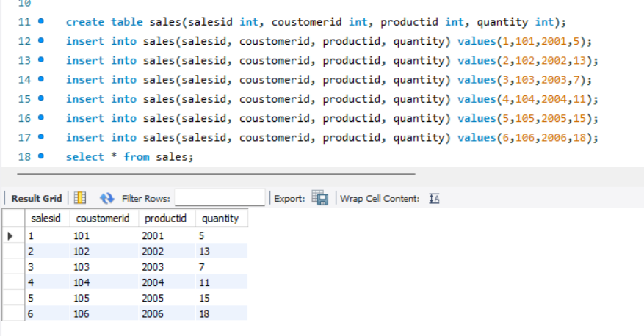

1. Create table customer- customer id, customer name, countary, age, aadharcard number(include necessary constraints)

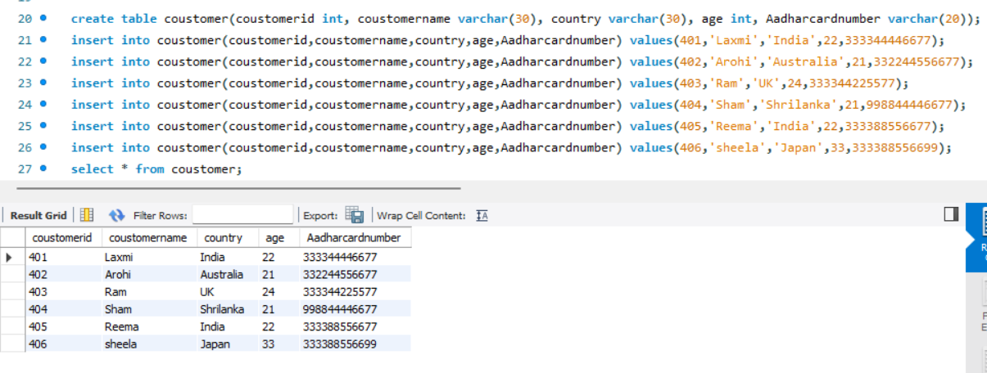

1. Show the product with maximum price.

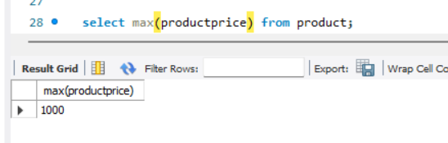

1. Show the sales with minimum quantity.

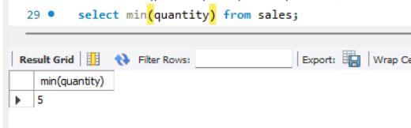

1. Show all the products whose names starts with A

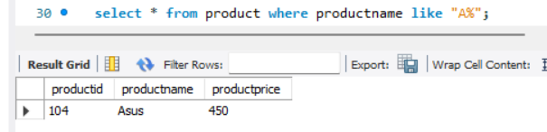

1. Show all the coustomers who are from Australia

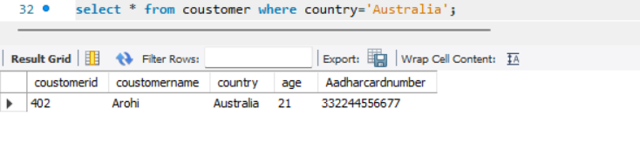

1. Show all the customer who are from japan and have age greater than 30

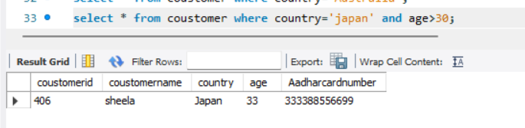

1. Show all the product with price range 200 to 500 rupees

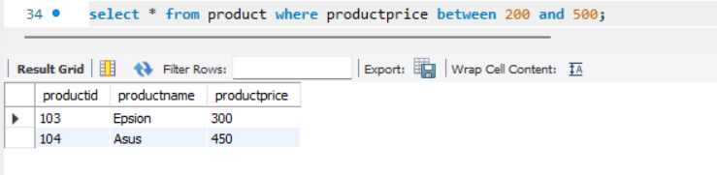

1. Show all the sales product where you will list the price and also the total amount paid per sales
2. Show all the products which are having price less than 200 or have the name starting with S.

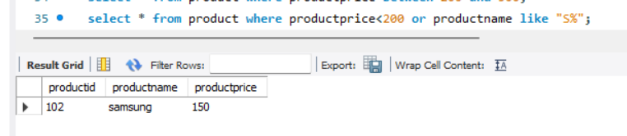

1. Change the name of customer 402 to Shakti

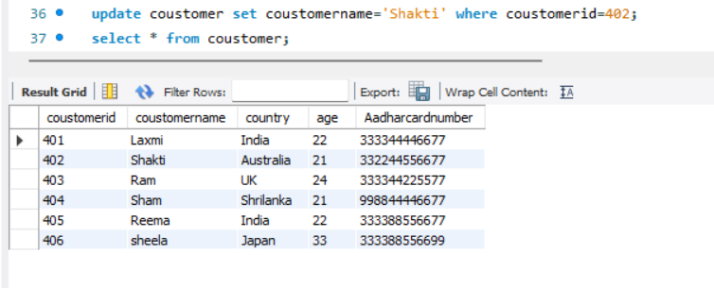

1. List down all the sales Id, product id, product name and quantity.
2. Search for all the customers from UK, Japan, Shrilanka.

